## Business Process - EdUSA

### Document Information

|  |  |
| --- | --- |
| **Author(s)** | MG |
| **Last Updated** | 01/24/2023 |
| **Project** | EdUSA |
| **Reference(s)** |  |

### 1. Introduction

### Business Purpose

EducationUSA is a U.S. Department of State network of over 430 international student advising centers in 178 countries and territories. The network promotes U.S. higher education to students around the world by offering accurate, comprehensive, and current information about opportunities to study at accredited postsecondary institutions in the United States. EducationUSA also provides services to the U.S. higher education community to help institutional leaders meet their recruitment and campus internationalization goals. EducationUSA is your official source on U.S. higher education.

### Tasks

Listed below are the Ed-USA business tasks,

* Capability to design custom forms using a cloud-based web application.
* Changes to forms deployed immediately.
* Field collection via Android or iOS mobile applications as well as desktop (via a browser).
* Data reporting functionality that includes visualization options and other data management tools (system should generate data in several industry-standard file types, including Excel, Word and PDF)
* System can generate reports from captured data in PDF format to send to stakeholders.
* Configurable options to manage teams and roles that define and control what users are permitted to do.
* Data synced to the cloud for storage and access by team.
* Platform capable of handling approximately 100 concurrent users.
* Personalized customer support, dedicated support professional during implementation phase.

### Key Contributors

|  |  |
| --- | --- |
| Roles | Expected Number of Users, Work styles, and preferences |
|  | * 5 users * Mainly uses a Desktop * Need full access to edit system * Create & edit forms, reports and other functions |
|  | * 30 users * Mainly uses a Desktop, but may prefer to use tablet and/or iPad * Read & write data * Responsible for approving the forms submitted by general users * Run reports |
|  | * 500+ users * Mainly uses a Desktop, but may prefer to use tablet, iPad or Mobile * Data entry for applicable forms * View and edit their own submitted forms |

### Business Process

### 2. Architecture

As you can see from the above business process, multiple types of business users deal with the same set of data.

### Technical Tenets

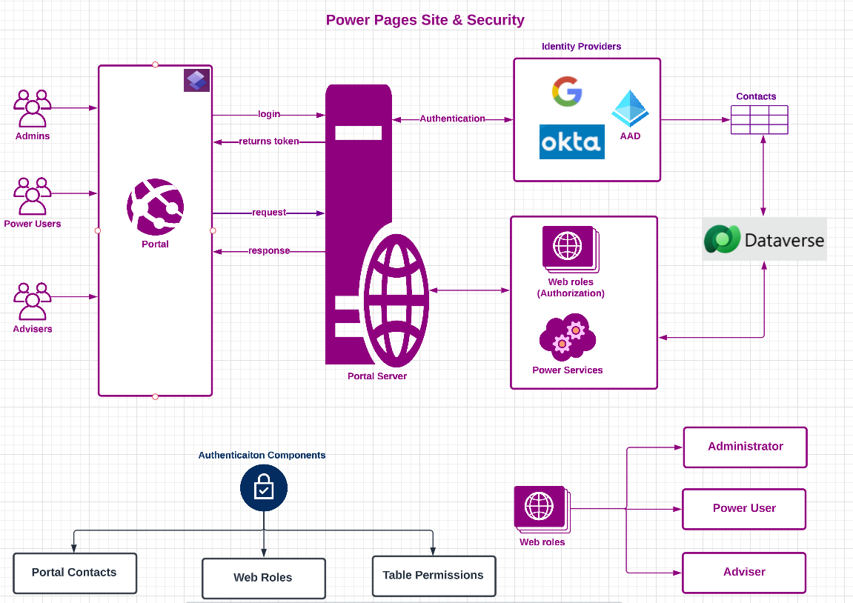

### Technical Tenets

Following are the architectural and technical tenets of Ed-USA business process,

* **Power Pages:** Power pages would be the best fit for **General user** filling in the forms and submitting to review of form details, where as **Power users** can review the form details. It is a secure, enterprise-grade, low-code software as a service (SaaS) platform for creating, hosting, and administering modern external-facing business websites.
* **Dataverse (aka Common Data Service):** Application’s data will be stored in Dataverse, which is a secure, cloud-based storage space. Logic has to be defined in Dataverse so that logic runs in the service rather than the device.

Data can be stored and retrieved in different ways as mentioned below,

* + **New Data**: Create a data that doesn’t already exist anywhere like advising centers, regions, countries, modules which deals with specific type of data points, activity report list and activity report details.
  + **Read/write from an existing system:** This is type of data where we need to retrieve the latest information from an existing database or system. In this case, data needs to be requested at the time we need it.
* **Securing the App and Data:** The design should consider one or more of the security levels mentioned below based on the need.
  + **App-level security:** Restrict access at app level. Users must have appropriate access to the underlying data.
  + **Form-level security:** Define security groups to access specific form(s) to allow only specific group of users to access form(s).
  + **Record-level security:** Assign access at record level in order to perform create, read, update and delete operations.

### 3. Power Pages pricing

|  |  |
| --- | --- |
|  | Authenticated Users |
| Fixed Price | $200 for 100 users/site/month  **Note: 100 users per capacity pack**  **EdUSA users (500 General Users + 30 Power Users + 5 Admin Users) = 535 users (i.e. 6 capacity packs) = $1200**  Each power pages authenticated users per website capacity pack subscription plan will receive 2 GB database capacity and 16 GB file capacity accrued to the tenant.  6 capacity pack(s) * 2 GB = 12 GB database capacity  6 capacity pack(s) * 16 GB = 96 GB file capacity |
| Pay-as-you-go | $4 per user/site/month  This is not a right choice for the current scenario |

### 4. Datavers tables

We will need to store our information of our process in Microsoft Dataverse tables.

### Advising Center

|  |  |
| --- | --- |
| Column Name | Column Data Type |
| Center Name | Text (Max char count: 256) |
|  |  |

### 4. Advising Center Activity

|  |  |
| --- | --- |
| Column Name | Column Data Type |
| Activity Number | Auto (Prefix: ACT, Seed: 1000, Min no of digits: 6) |
| Advising Center Name | Lookup: Advising Center |
| Adviser Name | Lookup: Contact |
| Data for Year | Choise: 2019, 2020, 2021, 2022, 2023 |
| Data for Month | Choise: Month |
|  |  |

### 5. Datavers tables